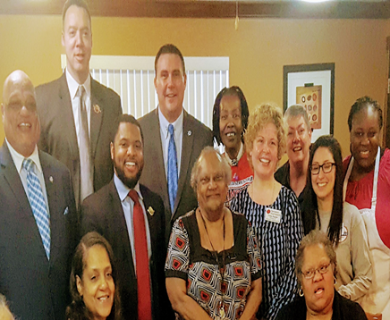Mayor Terry Epps, (L), Redditt Hudson, Darryl Jones II, and Michael McMillan all of the Urban League of Metropolitan Greater St. Louis, and Trina Ragain and her volunteers (center to right) spend time with seniors at Stratford Manor.

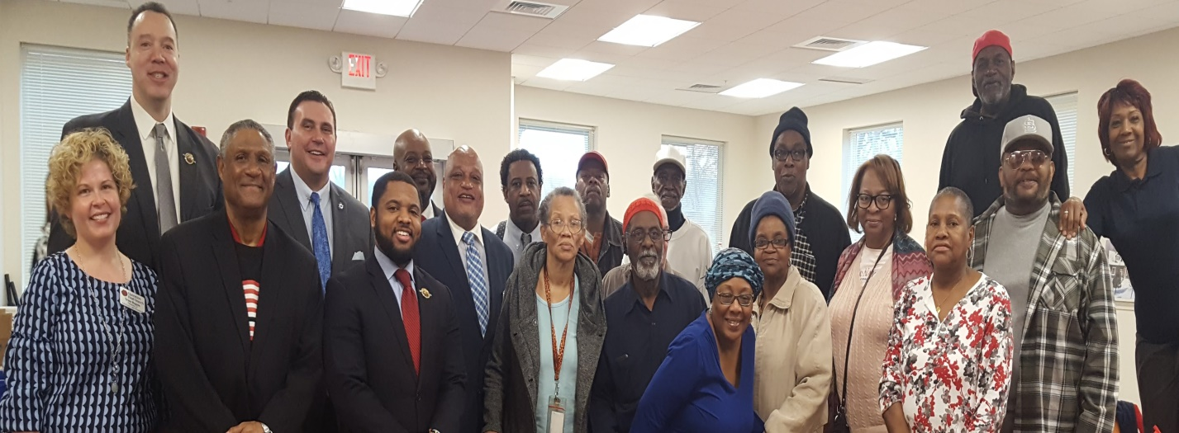 L to R, Trina Ragain, Redditt Hudson, Matthew Foggy, Michael McMillan, Darryl Jones II, David Wade, and Mayor Terry Epps pay a visit to seniors at Vetter Place, a senior living community.