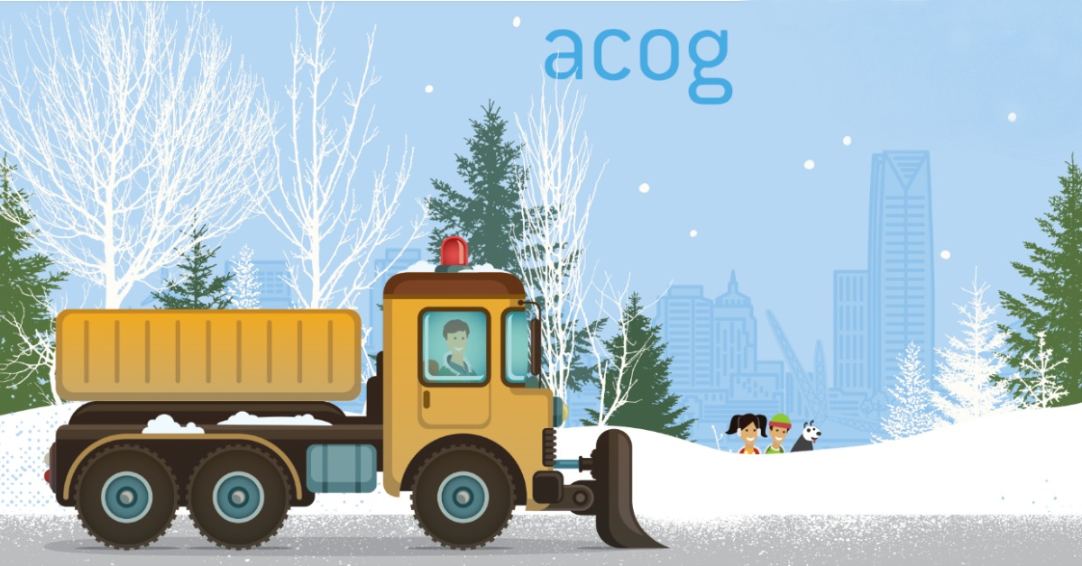
- S n o w R o u t e -

PARK in
Driveway
or

LEFT Side
of Street

